System Requirements Specification (SRS)

Project: Spaceship Interface (Arduino Starter Kit – Project 02)

1. Introduction
This document defines the system requirements for the Spaceship Interface project, based on the Arduino Starter Kit – Project 02. The system simulates a control interface using LEDs and a pushbutton and is designed to demonstrate basic control logic and interactive behavior. This specification adheres to the guidelines from INCOSE, IEEE 29148:2018, and ISO/IEC/IEEE 15288 standards.

2. Purpose
The purpose of this system is to simulate a spaceship control panel in a retro-futuristic style, where a button press changes the state of LED indicators, providing visual feedback similar to a control system. This system demonstrates interaction with digital inputs and outputs using the Arduino UNO R3 microcontroller.

3. System Overview
The Spaceship Interface consists of one input device (a pushbutton) and three output devices (one green and two red LEDs). The system operates in two modes:
1. Idle Mode: Green LED is ON, indicating standby.
2. Active Mode: Upon button press, the green LED turns OFF, and two red LEDs alternately blink at 250 ms intervals.

4. Interface Requirements
Type | Pin Number | Component | Description
Input | D2 | Pushbutton | Digital input that triggers mode change.
Output | D3 | Green LED | Indicates system is in idle mode.
Output | D4 | Red LED (Left) | Blinks in active mode.
Output | D5 | Red LED (Right) | Blinks alternately with LED on D4.

5. Functional Requirements
- FR-001: The system shall monitor the state of the pushbutton connected to pin D2.
- FR-002: The system shall illuminate the green LED on pin D3 when the button is not pressed.
- FR-003: The system shall turn OFF the green LED on pin D3 when the button is pressed.
- FR-004: The system shall cause the red LEDs on pins D4 and D5 to alternately blink at 250 ms intervals when the button is pressed.
- FR-005: The system shall resume idle state (green LED ON) when the button is released.

6. Behavioral Requirements
- BR-001: In idle mode (button not pressed), the green LED shall remain continuously ON.
- BR-002: In active mode (button pressed), the system shall initiate a blinking pattern alternating between the two red LEDs every 250 milliseconds.
- BR-003: Switching from active to idle mode shall be immediate upon button release, turning off the red LEDs and turning on the green LED.

7. Verification Methods
Each requirement shall be verified through functional testing with the Arduino hardware and an oscilloscope or logic analyzer to confirm timing and logic behavior of LEDs and button states.

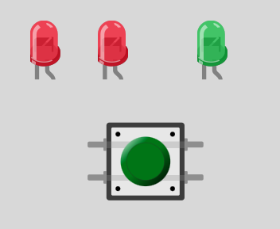

This page is an appendix and is not part of the requirements specification.
It is only for the teacher and contains only the code needed for teaching:
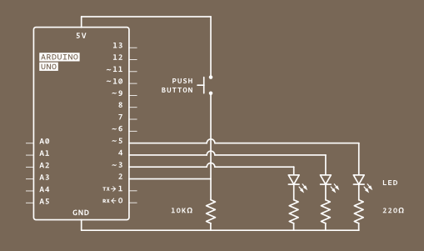

int switchState = 0; // Variable wird deklariert
void setup() {

// pinMode(): Definiert, ob ein Pin als Eingang (INPUT) oder Ausgang (OUTPUT) verwendet wird.
pinMode(3,OUTPUT);
pinMode(4,OUTPUT);
pinMode(5,OUTPUT);
pinMode(2,INPUT);

}
void loop() {

// digitalRead(): LiestdenZustandeinesdigitalenPins(HIGHoderLOW).WirdfürEingabegeräte wie Taster verwendet.
switchState = digitalRead(2);

if (switchState == LOW) { // the button is not pressed

digitalWrite(3, HIGH); // green LED
digitalWrite(4, LOW); // red LED
digitalWrite(5, LOW); // red LED

} else { // the button is pressed

digitalWrite(3, LOW);

digitalWrite(4, LOW);
digitalWrite(5, HIGH);

delay(250); // wait for a quarter second

// toggle the LEDs
digitalWrite(4, HIGH);
digitalWrite(5, LOW);

delay(250); // wait for a quarter second

}
} // go back to the beginning of the loop

